Step 1: Start
Begin the program.

Step 2: Take Input
Read an integer n from the user (number of rows).

Step 3: Loop Through Rows
Use a loop that runs from n down to 1.
Why?
Because:
- First row → n stars
- Last row → 1 star
So we go backwards.

Step 4: Print Stars in Each Row
For each row:
- Print i stars (*)
- Do not add spaces between stars
- Move to next line after printing

7.1.1 INVERTED STAR PATTERN

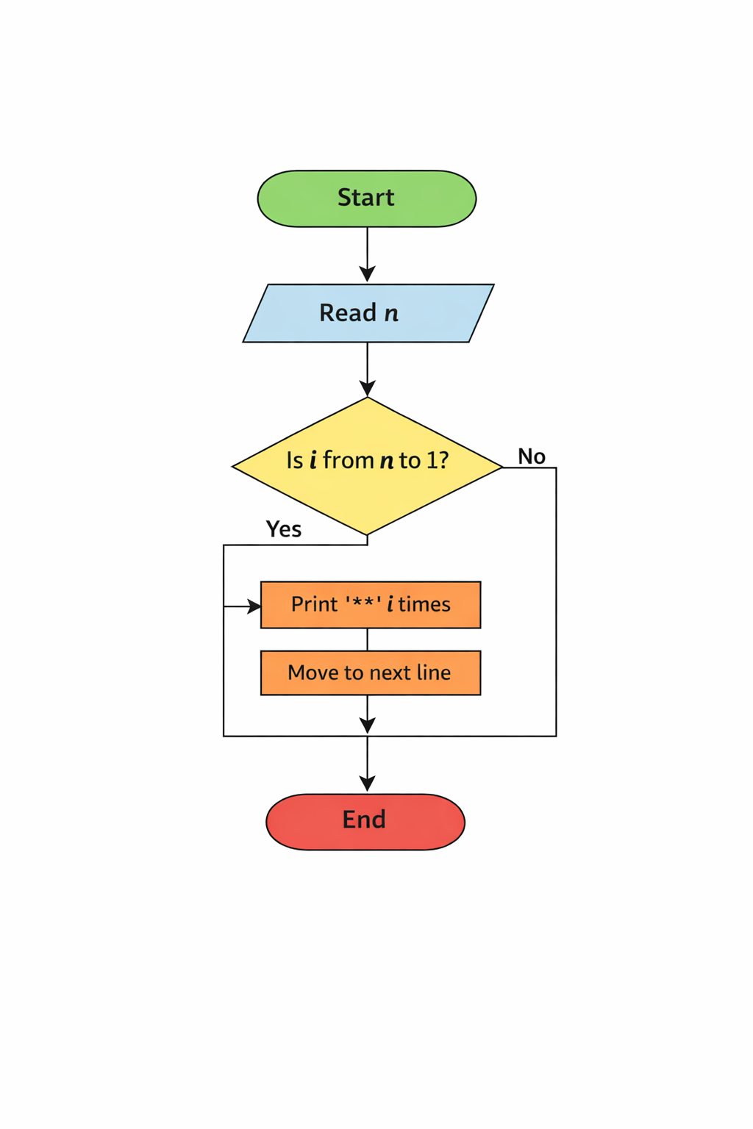

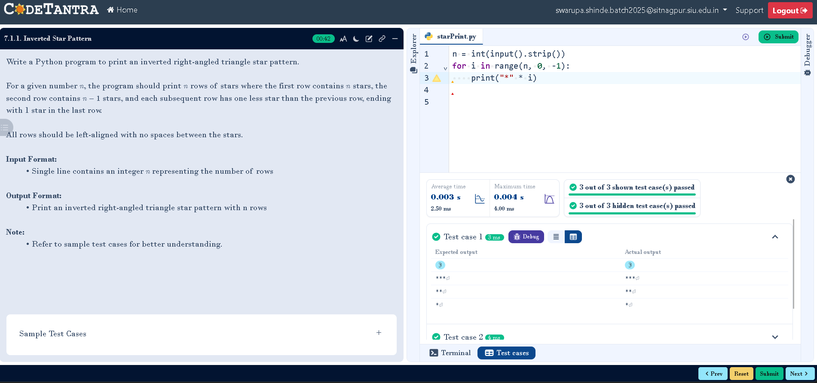
CODE:

